**Add comments while viewing a PDF document**

With the May 2019 release of Acrobat DC, you can use quick actions in a floating toolbar to add comments while viewing a PDF. You do not have to open the commenting tool to access these actions. The following quick actions are available for commenting based on your selection in a PDF:

**Note:**

If you are unable to see these options, update Acrobat DC to the latest version.

* **Actions on text selection**: You can Highlight Text, Underline Text, Strikethrough Text, Copy Text, and Edit Text & Images.

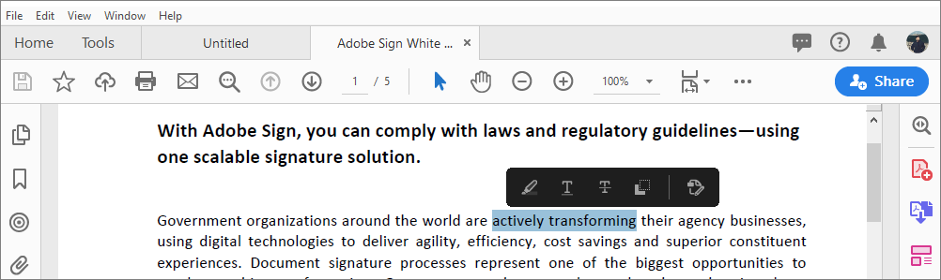

* **Actions on image selection:**When you select an image you can perform actions like Add Sticky Note, Highlight Text, Edit Text & Images, and Copy Image.

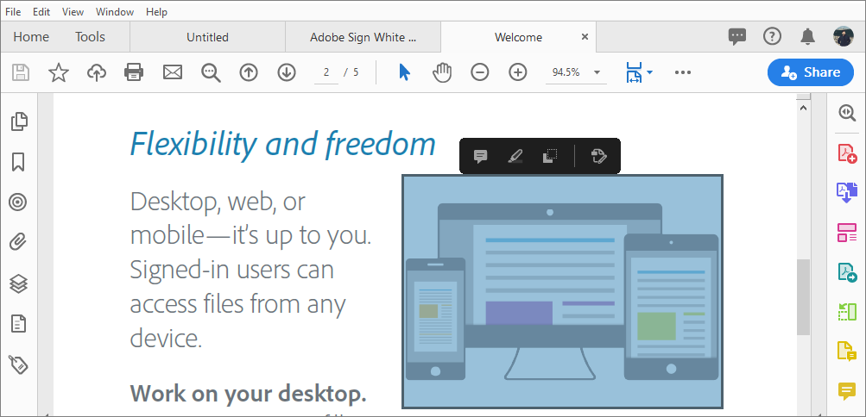

* **Actions on highlight selection:**When you select an existing highlight comment in a PDF you see quick actions to Add Note or Delete the comment.

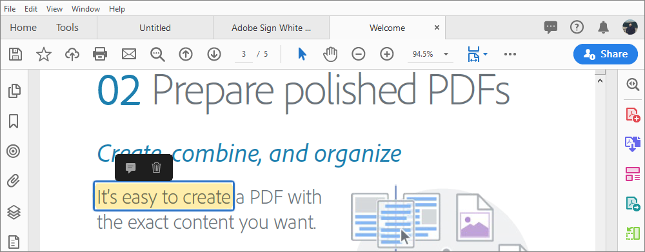

**Annotations and drawing markup tools overview**

***Note****: In Acrobat Reader, complete commenting tools are available only in PDFs that have*[*commenting enabled*](https://helpx.adobe.com/acrobat/using/preparing-pdf-review.html#enable_commenting_for_reader_users_acrobat_pro)*.*

You use annotation and drawing markup tools to add *comments*. The commenting tools are made available in the secondary toolbar of the Comment feature. Comments are notes and drawings that communicate ideas or provide feedback for PDFs. You can type a text message using the Sticky Note tool. Alternatively, you can use a drawing tool to add a line, circle, or other shape and then type a message in the associated pop-up note. Text-editing tools let you add editing marks to indicate changes that you want in the source document. Most commenting and markup tools don’t appear in the toolbar until you enable the Commenting feature.

**Note:**

*In Acrobat Pro, you can add tags to your comments so that readers with motion or vision limitations can read them using assistive technologies.*

**Show annotations and drawing markup tools**

Annotations and markup tools don’t appear by default, except when you open a PDF in a managed review workflow.

1. Choose **Tools** > **Comment** to open the Comment toolbar. The comments that you add to the document are displayed in the right pane.

Comment toolbar in Acrobat

*Comment toolbar*

**Note:**

*To see the labels along with the tool icons, right-click on the Comment toolbar and select****Show All Labels****.*

1. The drawing markup tools are grouped under the **Drawing Tools** menu. Click the **Drawing Tools**icon  on the toolbar, and then select **Expand Drawing Tools** to add the drawing tools to the secondary toolbar.

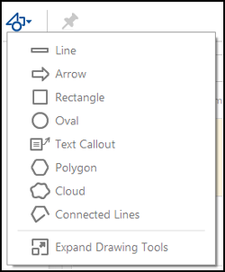

*Drawing Tools menu*

**Select an annotation or drawing markup tool**

* Open the **Comment** toolbar and select the desired annotation tool.
* To select the drawing markup tool, open the **Comment** toolbar and click the **Drawing Tools**icon . Select the desired tool from the **Drawing Tools** menu.

**Note:**

*After you make an initial comment, the tool changes back to the Select tool so that you can move, resize, or edit your comment. (****The Pencil****and****Highlight Text****tools stay selected.)*

**Keep an annotation tool selected**

You can add multiple comments without reselecting the tool.

1. In the Comment toolbar, select the tool you want to use (but don’t use it yet).
2. Click the **Keep Tool Selected** icon 

**Add a sticky note**

**Note:**

**In Acrobat Reader**, complete commenting tools are available only in PDFs that have commenting enabled. PDFs in a review workflow typically include commenting rights.

The most common type of comment is the sticky note. A sticky note has a note icon that appears on the page and a pop-up note for your text message. You can add a sticky note anywhere on the page or in the document area.

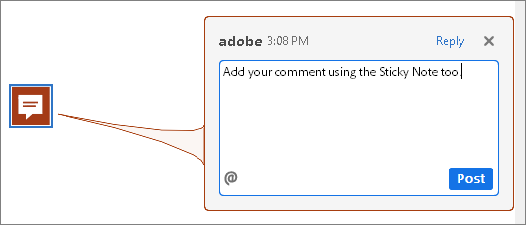

*Use the Sticky Note tool to add a text message in a pop-up note.*

**Add a sticky note comment**

1. Select the **Sticky Note** tool  in the Comment toolbar, and click where you want to place the note.
2. Type text in the pop-up note. You can also use the Select tool  to copy and paste text from a PDF into the note.

**Note:**

If you close the pop-up note, your text remains.

**Edit a sticky note comment**

1. Click or double-click the note icon.
2. Make changes, as needed:
   * To resize the pop-up note, drag the lower-left or lower-right corner.
   * To change the text formatting, click the **Text Properties** icon in the Comment toolbar, and select the text, and then select the property you want in the toolbar.

**Note:**

Use the Commenting panel in the Preferences dialog box to change the font size, default pop-up behavior, and other settings for creating and viewing comments

After making the desired changes, click the close (X) button in the upper-right corner of the pop-up note, or click outside the pop-up note.

**Copy partial text in a sticky note comment**

1. Click or double-click the note icon.
2. Select the text, and then right-click and copy text.

**Delete a sticky note**

1. Select the **Sticky Note** tool , the Hand tool , or the Select tool .
2. Select the note icon, and press **Delete**.

Alternatively, double-click the note icon and choose Delete from the Options menu of the pop-up note.

**Add a text comment**

Use the Add Text Comment tool  to type text anywhere on the PDF page. The Add Text Comment tool is similar to the Add Text Box tool.

1. Choose the **Add Text Comment** tool from the Comment toolbar.
2. Click on the page to place the cursor
3. To change the text formatting, click the **Text Properties** icon in the Comment toolbar, and select the text, and then select the property you want in the toolbar.

**Change author name for comments**

When you add a comment in a PDF file, by default your login name is used as author name for the comment. To change the author name, see [change author name for comments](https://helpx.adobe.com/acrobat/using/comments.html#Changeauthornameforcomments).

**Add a line, arrow, or shape**

**Note:**

**In Acrobat Reader**, drawing tools are available only in PDFs that have commenting enabled. PDFs in a review workflow typically include commenting rights.

When selecting a drawing tool, consider the effect you want.

1. Choose **Tools** > **Comment**. In the Comment toolbar, click **Drawing Tools**  and select the drawing markup tool:
   * The **Rectangle** tool , the **Oval** tool , the **Arrow** tool , and the **Line** tool  let you create simple shapes.
   * The **Cloud** tool  and **Polygon** tool  create closed shapes with multiple segments. The **Polygon Line** tool  creates open shapes with multiple segments.
   * The **Pencil** tool  creates free-form drawings, and the **Pencil Eraser** tool  removes the pencil markups.

**Note:**

To specify the line width, color, and other properties before you draw, select the desired tool, and press Ctrl+E to open the properties toolbar. Set the desired options in the Properties toolbar.

1. Draw in the PDF:
   * To create a cloud or polygon shape, click to create the start point, move the pointer, and click to create each segment. To finish drawing the shape, click the start point, or right-click and choose Complete from the menu. Double-click to end a polygon line.
   * To draw a line, arrow, or rectangle, either drag across the area where you want the markup to appear, or click twice: once to create the start point and once to create the end point.
   * To draw a square or circle, or to draw a line that’s horizontal, vertical, or at a 45° angle, press Shift while you draw.
   * To draw free-form lines using the **Pencil** tool , drag where you want to begin drawing. You can release the mouse button, move the pointer to a new location, and continue drawing. To erase parts of the drawing, select the **Pencil Eraser** tool  and drag across the areas of the drawing that you want to remove.
2. To edit or resize the markup, select it and drag one of the handles to make your adjustments.
3. To add a pop-up note to the markup, select the Hand tool, and double-click the markup.
4. (Optional) Click the close button in the pop-up note. A note icon appears to the right of the markup to indicate the presence of text in the pop-up note.

**Note:**

To delete a drawing markup, select it and press Delete.

**Group and ungroup markups**

You can group two or more markups so that your comments function as a single comment. You might group markups temporarily to move them to a new location or to modify their properties rather than editing each one individually. Grouping also helps to distinguish your markups from other reviewers’ markups in a document review.

**Note:**

You cannot group text edit markups.

**Group markups**

1. Using the Select tool or the Hand tool, select a markup.
2. Ctrl-click/Command-click to select the markups you want to group.
3. Right-click within the selection, and choose **Group**.

**Ungroup markups**

1. Right-click the grouped selection, and choose **Ungroup**.

**Add comments in a text box or callout**

**Note:**

**In Acrobat Reader**, commenting tools are available only in PDFs that have commenting enabled. PDFs in a review workflow typically include commenting rights.

You can use the **Text Box** tool  to create a box that contains text. You can position it anywhere on the page and adjust it to any size. A text box remains visible on the document page; it doesn’t close like a pop-up note.

Text font and size are based on the system default settings.

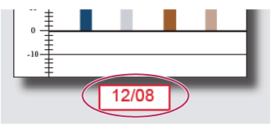

**Note:**

You can add comments to Japanese, Chinese, and Korean text with the **Text Box** tool, but you must have the Asian-language resource files installed. Text boxes allow for horizontal text only.

You can use the Callout tool  to create a callout text box. Callout text boxes are especially useful when you want to single out—but not obscure—a particular area of a document. Callout text boxes have three parts: a text box, a knee line, and an end-point line. You can resize each part by dragging a handle. The knee line can be resized in one direction only; horizontal knee lines can be resized horizontally only; vertical knee lines can be resized vertically only. The text box expands vertically as you type so that all text remains visible.

You can move the text box itself or together with the end-point line. The text box moves around a stationary anchor point—the arrow on the end-point line—which is created when you first click in the PDF. You can modify the color and appearance of the text box and add arrows or leaders to the end-point line.

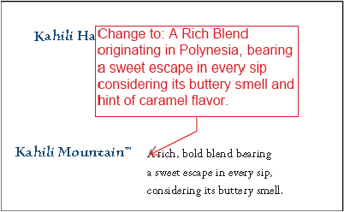

**Add a text box**

1. Choose the **Add Text Box**  tool from the Comment toolbar.
2. Click in the PDF.
3. Choose the **Text Properties** icon in the Comment toolbar, and then select the color, alignment, and font attributes for the text.
4. Type the text.

Text wraps automatically when it reaches the right edge of the box.

1. (Optional) To make further changes to the text box:
   * Using the **Select** tool or the **Text Box** tool, click an edge of the text box to select it, and then drag a corner to resize it. Use the **Properties** toolbar to change the border and fill options.
   * Double-click the text box to edit the text or change the text attributes. Drag across text to select it, and then select options from the **Properties** toolbar.
2. To delete the text box, select it, and then press **Delete**.

**Note:**

You can also paste a block of text by selecting and copying the text in any application, selecting the Hand tool in Acrobat, and choosing Edit > Paste.

**Add a callout**

1. In the Comment toolbar, click **Drawing Tools**  and choose the **Add Text Callout**  tool.
2. Click once to set the location of the end point, and click again to set the location of the text box.
3. Choose the **Text Properties** icon in the Comment toolbar, and then select the color, alignment, and font attributes for the text.
4. Type the text.

Text wraps automatically when it reaches the right edge of the box.

1. (Optional) To make further changes to the text box:
   * To resize the callout, select it and drag any of the handles that appear.
   * To move the text box, click inside the box and drag it.
   * To move the entire callout, click either the end-point line or an edge of the text box, and drag it.
   * To change the color, opacity, or line characteristics, use the Select tool to right-click the callout, choose Properties, and select the options you want.

**Add an audio comment**

**Note:**

**In Acrobat Reader**, commenting tools are available only in PDFs that have commenting enabled. PDFs in a review workflow typically include commenting rights.

You can use the **Record Audio Comment** tool to add a prerecorded WAV or AIFF file as a comment or to record and place an audio comment in a document. Audio attachments appear in the Comments list and can be played back on any platform. However, the appropriate hardware and software for playing audio files must be installed.

**Add a prerecorded audio comment**

1. Choose the **Record Audio**  tool from the Comment toolbar.
2. Click in the PDF where you want to place the audio comment.

The Sound Records dialog box appears.

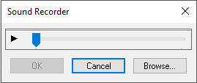

*The Sound Recorder dialog box without the record button.*

**Note:**

The above dialog box appears when a recording device is not configured on your system.

1. Click **Browse** (Windows) or **Choose** (**Mac OS**), and select the audio file you want to add.
2. (Optional) To hear the audio comment, click the **Play** button . When you’re finished, click the **Stop**button  and then click **OK**.
3. Specify options in the **Specify Attachment Properties** dialog box, and then click **OK**.

**Record an audio comment**

**Note:**

Before you record an audio comment, ensure that your system has a recording device installed and configured.

1. Choose the **Record Audio**  tool from the Comment toolbar.
2. Click in the PDF where you want to place the audio comment.

The Sound Recorder dialog box appears.

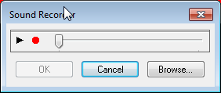

*The Sound Recorder dialog box with the record button.*

**Note:**

The above dialog box appears when a recording device is configured on your system.

1. In the dialog box that appears, click the **Record** button  and then speak into the microphone. When you’ve finished recording, click the **Stop** button , and then click **OK**.
2. Specify options in the **Sound Attachment Properties** dialog box, and then click **OK**.

**Add comments in a file attachment**

**Note:**

**In Acrobat Reader**, commenting tools are available only in PDFs that have commenting enabled. PDFs in a review workflow typically include commenting rights.

Use the **Attach File** tool to embed a file at a selected location in a PDF, so that the reader can open it for viewing. By adding attachments as a comment, you can reference longer documents that can’t easily be pasted into a pop-up note or text box. If you move the PDF to a new location, the embedded file automatically goes with it. To view an attachment, the reader must have an application installed that can open the attachment.

**Note:**

Be sure to use the Attach tool when attaching files for a document review. Document-level file attachments that you attach using the Attach A File tool  from the Tools > Edit PDF > More menu aren’t tracked with other comments in a review workflow and may cause your attached comments to be lost.

1. Choose the **Attach File**  tool from the Comment toolbar.
2. Click in the PDF where you want to place the attachment.
3. Select the file that you want to attach, and then click **Open**. If you’re attaching a PDF, you can highlight areas of interest in the file using comments.
4. In the **File Attachment Properties** dialog box, select the settings for the file icon that appears in the PDF.

The comment attachment also appears in the Attachments tab (in the left navigation pane) with a page number indicating its location.

**Note:**

To delete the attachment, right-click the attached comment icon, and choose Delete.

**Paste images as comments**

**Note:**

In Acrobat Reader, commenting tools are available only in PDFs that have commenting enabled. PDFs in a review workflow typically include commenting rights.

You can use the Paste Clipboard Image As Stamp Tool to add images to a PDF. You can copy most image formats from drawing and image-editing applications, such as **Adobe Photoshop** and Adobe Illustrator. If you want to add the image to PDFs repeatedly, create a custom stamp of the image.

**Note:**

The **Paste Clipboard Image As Stamp** Tool isn’t available until you copy an image.

1. Copy an image by doing one of the following:
   * In Acrobat, choose **Edit** > **Take A Snapshot** , and select an image from a PDF.
   * In another application, select an image and choose **Edit** > **Copy**.
2. Open a PDF.
3. Choose **Tools** > **Comment**. In the Comment toolbar, click the **Add Stamp**  tool and select **Paste Clipboard Image As Stamp Tool**.
4. Click in the PDF where you want the image to appear.
5. Do any of the following:
   * To move the image, drag it.
   * To resize the image, select it and then drag one of its handles. Press the Shift key when resizing the image to maintain the original proportions.
   * To change the image properties, right-click it and choose Properties.
   * To delete the image, right-click it and choose **Delete**.

**Commenting preferences**

Commenting preferences affect both the appearance of and the way you view annotations and markups in PDFs.

**Note:**

*A reviewer can place comments anywhere within the document frame. As a result, sometimes you need to scroll or zoom out to see comments that are located off the page.*

In the Preferences dialog box under Categories, select Commenting.

**VIEWING COMMENTS**

**Font, Font Size**

**In Windows**, you can determine the font and the size of text in pop-up notes. In **Mac OS**, you can select only Large, Medium, or Small settings for the font. This setting applies to all new and existing comments.

**Pop-up Opacity**

Determines the opacity of comment pop-up notes in values from 1 to 100. When a pop-up note is open but not selected, an opacity value of 100 makes the note opaque, while lower values make it more transparent.

**Enable Text Indicators And Tooltips**

Shows a tool tip when you place the pointer over a comment that includes a pop-up note. The tool tip contains the author name, comment status, and two lines of the text. Selected by default.

**Print Notes And Pop-ups**

Specifies that pop-up notes associated with comments, and icons for note, audio, and file attachments print exactly as they appear on the page.

Instead of selecting this option, you can print comment text in various layouts by choosing File > Print, and click **Summarize Comments**. For more details, refer the document to [print comments](https://helpx.adobe.com/acrobat/kb/print-comments-acrobat-reader.html).

**Show Lines Connecting Comment Markups To Their Pop-ups On Mouse Rollover**

When you place the pointer over a comment markup (such as a highlight or a note icon), the shaded connector line appears. Selected by default.

**Ensure That Pop-ups Are Visible As The Document Is Scrolled**

As you scroll a PDF, the pop-up notes on a given page shift to stay in view within the document pane. Selected by default.

**POP-UP OPEN BEHAVIOR**

**Automatically Open Comment Pop-ups For Comments Other Than Notes**

A pop-up note appears when you create a comment using a drawing tool, the Stamp tool, or the Pencil tool.

**Hide Comment Pop-ups When Comments List Is Open**

Helps reduce screen clutter when a page includes many comments. Selected by default.

**Automatically Open Pop-ups On Mouse Rollover**

When you place the pointer over a comment of any type, including drawing markups and stamps, the pop-up note opens.

**MAKING COMMENTS**

**Always Use Log-in Name For Author Name**

Determines which name appears in the pop-up note you create. If this option is selected, the **Login Name** in the Identity panel of the Preferences dialog box is used. If this option isn’t selected, the default name you specify for Author in a comment properties dialog box is used. Selected by default.

**Create New Pop-ups Aligned To The Edge Of The Document**

Aligns pop-up notes with the right side of the document window, regardless of where the comment markup (such as a note icon or highlighting comment) is added. If this option is deselected, the pop-up note appears next to the comment markup. Selected by default.

**Allow nested reply to sticky notes (requires restart)**

Allows reply to Sticky Notes with a single-thread experience. If this option is selected, each annotation appears like a conversation and all replies appear like a single-thread experience.

**Enable Text Selection For Highlight, Strikethrough and Underline**

Allows you to select and copy text for highlight, strike-through, and underline comments

**Show checkbox**

Displays the checkbox consistenty for all comments.

**MAKING COMMENTS (ACROBAT SPECIFIC)**

**Copy Encircled Text Into Drawing Comment Pop-Ups**

Copies text that you circle using the drawing tools in the pop-up note associated with the drawing markup.

**Copy Selected Text Into Highlight, Cross-Out, And Underline Comment Pop-ups**

Copies selected text to the pop-up note associated with text editing comments, such as those created by the **Highlight Text** tool.

**Change the look of your comments**

**Note:**

**In Acrobat Reader**, complete commenting tools are available only in PDFs that have commenting enabled. PDFs in a review workflow typically include commenting rights.

You can change the color and appearance of comments or markups before or after you create them. You can set the new look as the default appearance for that tool.

**Note:**

*To change how your name appears in comments, open the Preferences dialog box, select Commenting, and then deselect Always Use Log-in Name For Author Name.*

For the selected tool, you can use the Color Picker and Text Properties icons availabe on the Comment toolbar.

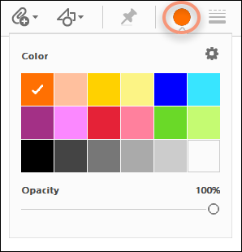

*The Color Picker tool on the Comment toolbar*

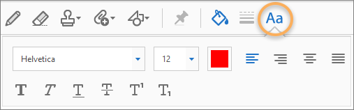

*The Text formatting tool on the Comment toolbar*

Alternatively, you can choose Properties from the right-click context menu, and then select appropriate options.

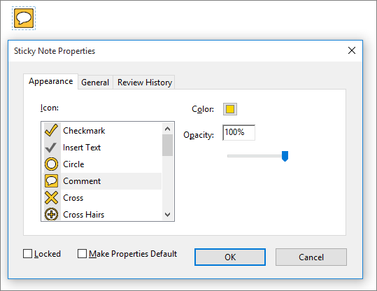

*Properties, with note icon selected*

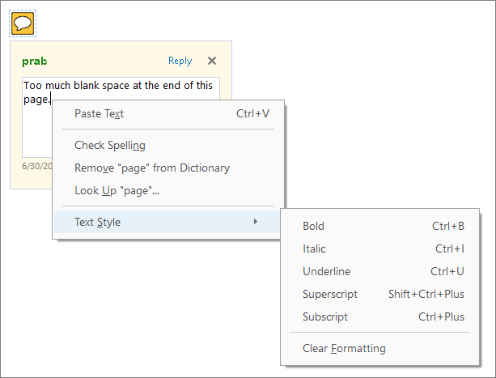

*With pop-up text and formatting options*

**Change a comment’s look and set it as the default**

1. After you create a comment, right-click the comment or its icon and then choose Properties from the righ-click context menu.
2. In the Properties dialog box, do any of the following, and then click **OK**:
   * Click the Appearance tab to change such options as the color and type of icon used. The type of comment selected determines which options are available.
   * Click the General tab to change the name of the author and subject of the comment.
   * Click the **Review History** tab to see the history of changes people have made to the status of a comment during a review.
   * Select Locked at the bottom of the Properties dialog box to prevent the comment from being edited or deleted.
   * Select **Make Properties Default** at the bottom of the Properties dialog box to apply these properties to all subsequent comments of this type.

**Set the default look for a tool**

1. After you create a comment, right-click the comment and choose **Properties**.
2. Set the properties as desired, and click **OK**.
3. Right-click the comment and choose **Make Current Properties Default**.

All comments you create using this tool display the properties you set. Existing comments aren’t affected, nor is the appearance of text in pop-up notes.

**Draw attention of a reviewer to your comment**

Use @mentions to get attention of any reviewer.

**Note:**

When you use @mention in your personal commenting notes in a PDF file, the review mode gets enabled for you. The reviewers get an invitation email with a link to the Document Cloud shared review file.

1. In the comment text, click the @ symbol.

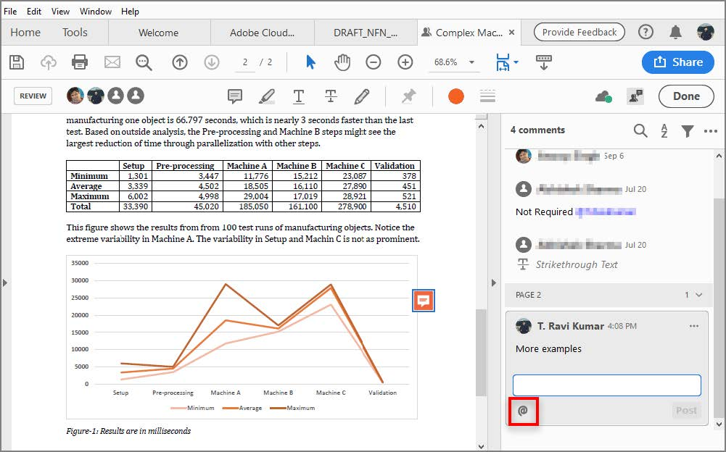

1. A popup menu will appear with a list of reviewers. Choose the reviewer you want to mention.